**DELHI SKILL AND ENTERPRENEURSHIP UNIVERSITY**



**INSTITUTE OF INNOVATION IN TECHNOLOGY & MANAGEMENT**

**Foss (Linux)**

***PRACTICAL FILE***

**BCA-1**

Submitted To: Submitted By:

Dr.Shilpa Bahl Name: Sachin Rajbhar

(Professor) Class: BCA 1A

Enrolment No: 41221139

|  |  |  |  |
| --- | --- | --- | --- |
| **Practical No** | **Objective** | **PRACTICALs** | **Sign** |
| P1 |  |  |  |

Practical 1

Q: Write the linux command to display the calendar with various options.

Command: Calendar

Syntax: cal

Description: This command displays the calendar on the screen

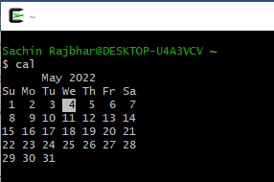

Options:

Cal -3

Description: This command displays three months –previous, current and next

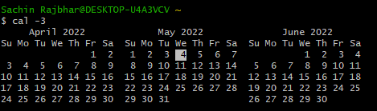

Cal –s

Description: This command displays the month with first day as Sunday

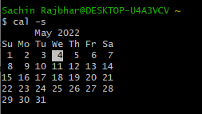

Cal -m

Description: This command displays the month with first day as Monday

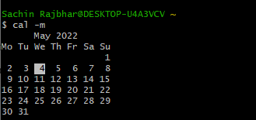

cal -y

Description: This command displays calendar of whole year

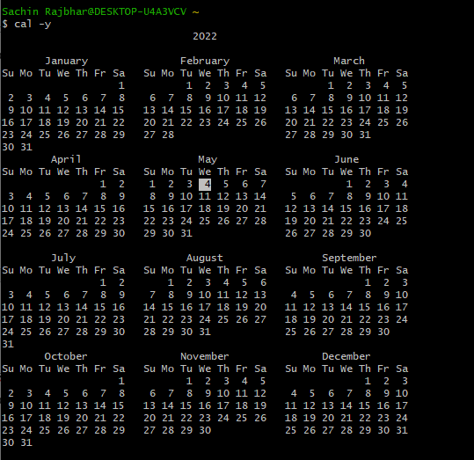

Practical 2

Q: Write a Linux command to display date with various options.

**Command:** date

**Syntax:** date

**Description:** This command is used to display the current date with time. There are various methods to display date. Some of them are as follows:

* Date: used to display the date with time.



* %u: used to display day of week (1..7); 1 is Monday.



* %y: used to display the year



* %m: used to display the current month.



* %a: used to display locale's abbreviated weekday name (e.g., Sun).



Practical 3

Q: Write a Linux command to display the list of users who are currently using Linux server.

Command: pwd (present working directory)

whoami

Syntax: pwd

whoami

Description: this command is used to display the list of users who are currently active on Linux server. There are various ways to implement this command. Some of them are as follows:

* pwd: display the present working directory.



* whoami: prints information about all the users.

